



**2022-2023 SPRING**

| **MACHINE LEARNING APPLICATIONS IN ARCHITECTURE** |
| --- |

**FINAL REPORT**

| **CONTINUOUS MERGING OF**  **STRANGE ATTRACTORS** |
| --- |

**OZGUR GULSUNA**

**Problem Definition**

Dynamical systems are mathematical models of various biological, physics phenomena and relate to how systems evolve over time. In a mathematical sense, dynamical systems consist of a set of variables that change over time according to a set of rules.

There exist dynamical systems in which some converge to a single solution, some diverge to infinity, some are periodic. Between the behaviors of dynamical systems, the most interesting or one can also say strange, is the chaotic behavior. It refers to systems that exhibit sensitive dependence on initial conditions meaning that even tiny differences in starting conditions lead to dramatically different outcomes.

In studying dynamical systems, is the notion of attractors. An attractor is a subset of the system's state space that the system tends to evolve over time. In regular systems, attractors are often simple, such as fixed points or limit cycles. However, in chaotic systems, attractors can exhibit intricate geometric structures known as strange attractors. These strange attractors have fractal properties.

Finding a strange attractor involves studying and analyzing the dynamics of a physical system using mathematical models or experimental data. Creating new systems on the other hand, involves minor modification to be made on existing systems but the resulting systems tend to be visually similar to the original system.

A new approach in creating a novel strange attractor is to combine the mathematical representations of different systems. By merging two or more attractors in a transitional state manner, it is possible to generate geometric structures that cannot be easily created using simple mathematical representations alone.

Two methods for combining state transitions can be considered. The first method involves altering the system's dynamics based on time. This means that the system's trajectory changes over different time periods, following a transition pattern. The second method involves spatial combination, where the system's space is divided into regions, and each region corresponds to a different system. For this project, the second method is preferred because it offers greater flexibility in working with spatial elements like surfaces, spheres, or other planar structures.

More than a hundred chaotic attractors have been discovered to date, and the project aims to combine any attractor with others in a spatial manner with a single surface separating them. However, it is unlikely that any separating surface would work. Is there a planar surface that exists for two selected systems? We'll have to wait and see.

**Brief: Material**

The two random chaotic attractor systems and undefined plane parameters, or all of the mathematically possible planes is the material of the problem. The chaotic attractor systems have various dimensions ranging from 3 to 11. The multidimensionality aspect is coped with picking the first three dimensions of the systems and working with those solely; however as a future work the plane definitions can be enlarged to a hyperplanes that can divide higher dimensional spaces.

**Brief: Observation**

Assuming that a plane exists for two selected strange attractor systems in which the resultant system is also chaotic, the search for this plane should not be manual, as it would be time-consuming and require a significant amount of human labor. Instead, a computational approach should be used to expedite the search and reduce the amount of human involvement.

**Brief: Model**

The model is a black box that can find a plane for two selected attractor systems within a small time with chaotic behavior, or result in non-existence of the optimum plane.

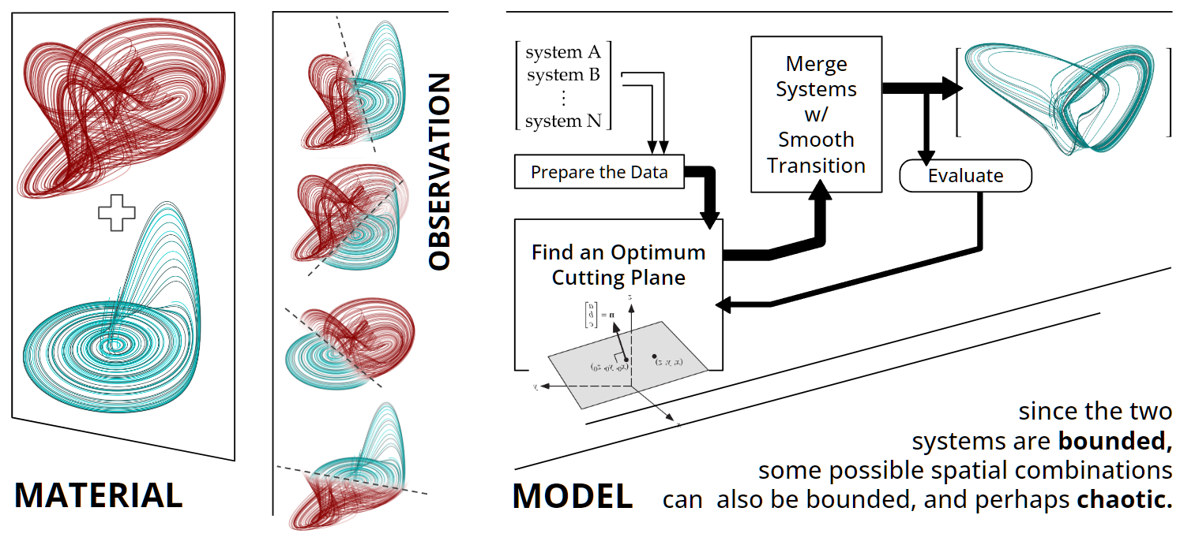

*Fig. 1: Material, Observation and Model*

The model can be represented by a flowchart as follows:

1. Select two chaotic attractor systems.
2. Perform preprocessing, such as normalization and parametrization of the plane.
3. Apply the algorithm to alter the parameters in an intelligent way to find a plane.
4. Evaluate the combined systems with plane.
5. Display the results in three dimensions.

The expectations for the outcome of the project were uncertain at the outset. The initial idea was that since the two strange attractor systems are bounded, the resulting system could also be bounded, and hence there could exist a non-trivial, or chaotic combination. Preliminary experiments showed that with some randomly selected planes, visually chaotic trajectories are acquired, but the ratio of chaotic to trivial results was quite low.

**Data Preparation**

The data for this project is in a contained format, meaning that the system of equations for different strange attractors is contained within a Python library called "dysts." These equations must be evaluated to obtain the time series or trajectories, which are in a more expanded form. Since the combining operation requires the equations rather than the evaluated values, this library is preferred.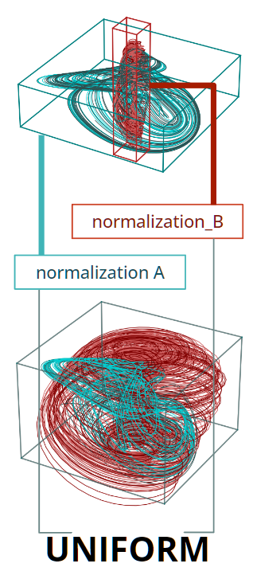

Every strange attractor system is limited in range and can be contained in a bounding box (habitat) with its own dimensions. However, this poses a challenge when it comes to spatial combination. If the inputs to the system originate from outside its habitat, the system may prematurely diverge to infinity. To address this issue, the systems need to be normalized. The normalization process involves simulating the system, determining scaling and offset factors, and then applying linear transformation matrices to convert the simulation results into a unit box situated at the origin. This normalization ensures that the systems operate within a consistent and manageable range, enabling effective spatial combination.

A side note that evaluation of combined systems depends on numeric calculation of trajectories, in other words the combined system is simulated and the evaluation is made on the time series output.   
 *Fig. 2: Normalization*

Parametrization should be made on the dividing plane as a preprocessing. This means that a mathematical model for the plane should be prepared and to be iterated using the model in the next section. The basic plane model is as,

While selecting random values for , , , and is sufficient to generate a random plane, the resulting planes will not be uniformly distributed. For example, a vertical plane will have as the highest value and as the lowest value, but random distributions for these parameters will result in most planes having values close to 0.5, meaning that most planes will be horizontally situated.

A more effective approach is to create a horizontal plane and then apply random rotations in three dimensions, such as r, theta, and phi. This will ensure that the plane has an evenly distributed normal vector, which will allow it to better cover the solution spectrum.

**Model Selection**

The computation model selected is a genetic algorithm, which is an optimization technique inspired by natural selection. It works by creating a population of potential solutions to a problem. Each solution is evaluated based on its fitness, or how well it solves the problem. The fittest solutions are then selected to reproduce, which involves combining their genetic material through crossover and introducing random changes via mutation. This process is repeated over multiple generations, gradually improving the population's overall fitness. By mimicking the principles of evolution, genetic algorithms can explore and converge towards optimal or near-optimal solutions for complex problems in various domains.  
  
To delve further into the model, a few definitions are in order.  
**Individual:** a solution candidate, which is a plane hence, has one gene and a fitness value.  
**Gene:** consist of phenotypes of the individual, for our case rotation (r, theta, phi ). **Population:** a group of individuals to be selected, reproduced and mutated.  
 **Elites:** partition of population which are directly moved to the next generation.  
 **Parents:** partition of population eligible for reproduction.  
 **Children:** generated through crossover of genes from parents.  
 **Rest:** Rest of the population, mutated and moved to the next generation.

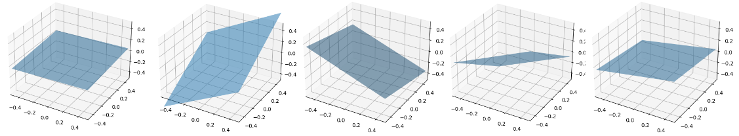

*Fig. 3: Exemplary Individuals*

**Correlation of the model and the Problem**

The problem at hand can be effectively addressed using a genetic algorithm, owing to its strong alignment with both the model and the demands of the problem. One key aspect is the non-uniqueness of possible planes for the selected system. With its inherent capability to explore diverse solutions, the genetic algorithm can identify multiple planes that exhibit comparable performance for our system. Moreover, the genetic algorithm excels in tackling the vast solution space, particularly when dealing with an increased number of planes, regions, or dimensions. While the solution found within a given timeframe may not be the optimal one, it remains a valid answer. Additionally, our data lacks labeled sets, consisting solely of mathematical relationships within the systems. This raw information is unsuitable for alternative algorithms like neural networks or regression-based solutions, necessitating preprocessing. Here the genetic algorithm is more suited.

**Performance Criteria**

Our understanding of the intended outcome is somewhat imprecise. We aim for the resultant systems combined with the plane to exhibit neither convergent nor divergent behavior; instead, we anticipate them to display chaotic dynamics. However, determining whether an attractor system is truly behaving chaotically poses a challenge. Various metrics exist to assess the desired behavior, and the most suitable metric for our model is the Lyapunov exponent, which closely aligns with our objectives. It quantifies the rate at which nearby trajectories in phase space diverge or converge over time. If the Lyapunov exponent is positive, it indicates exponential divergence, suggesting the system is chaotic. In contrast, a negative Lyapunov exponent implies convergence, indicating a stable and predictable behavior. By calculating the Lyapunov exponent, we can assess the sensitivity of the system to initial conditions and determine whether it exhibits the desired chaotic behavior.

**Parameters**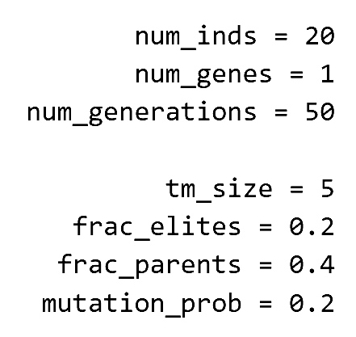

The model has several parameters that can be modified to adjust the process. The number of individuals determines the population size. Generally, a larger population will find the optimal solution more quickly, but it will take longer. The gene number is set to one because the model has only one plane. Tournament selection is used to select parents, which helps to give not-so-well-performing individuals a random chance of being selected. The fractions of elites sets the percentage of elites in the population. The mutation probability is the rate of mutation that is applied to children and rest. *Fig. 4: Parameter Table for Algorithm*

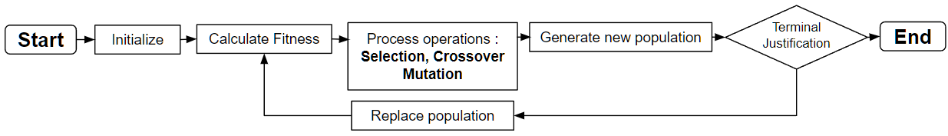

*Fig. 5: Genetic Algorithm Flowchart*

**Results**

The results show that our model is able to find a plane which will divide the space such that the spatial combination of the selected systems is indeed a chaotic attractor system. A crucial metric indicating the success of the algorithm is the fitness plot, which presents the fitness values plotted against the generations.

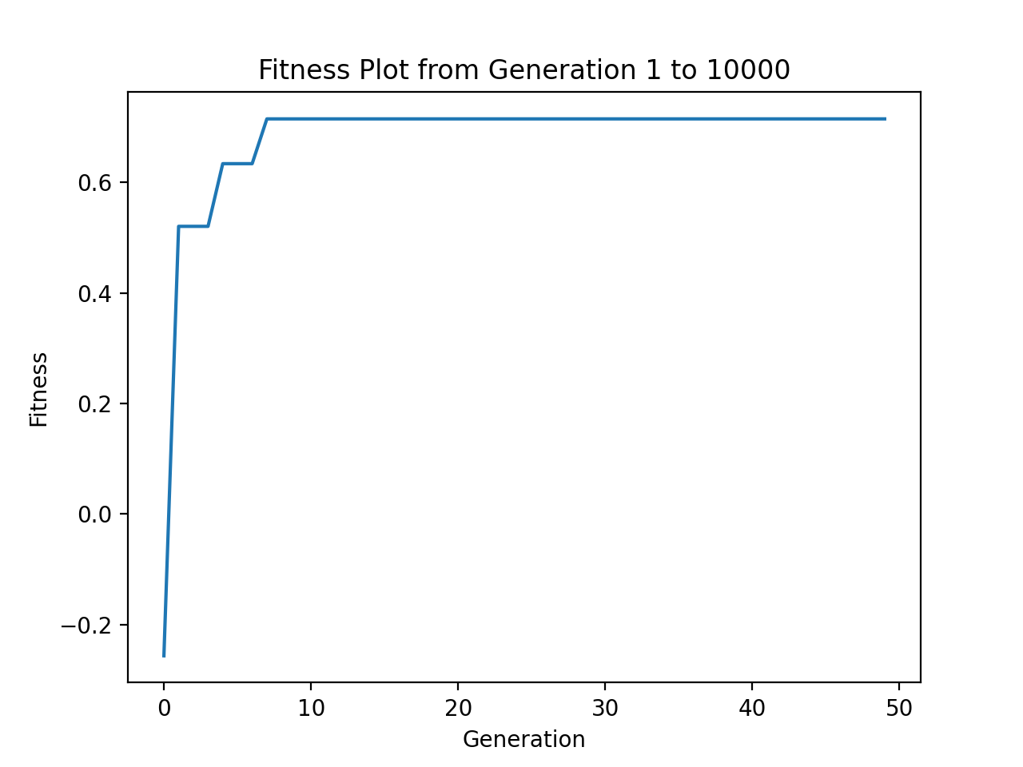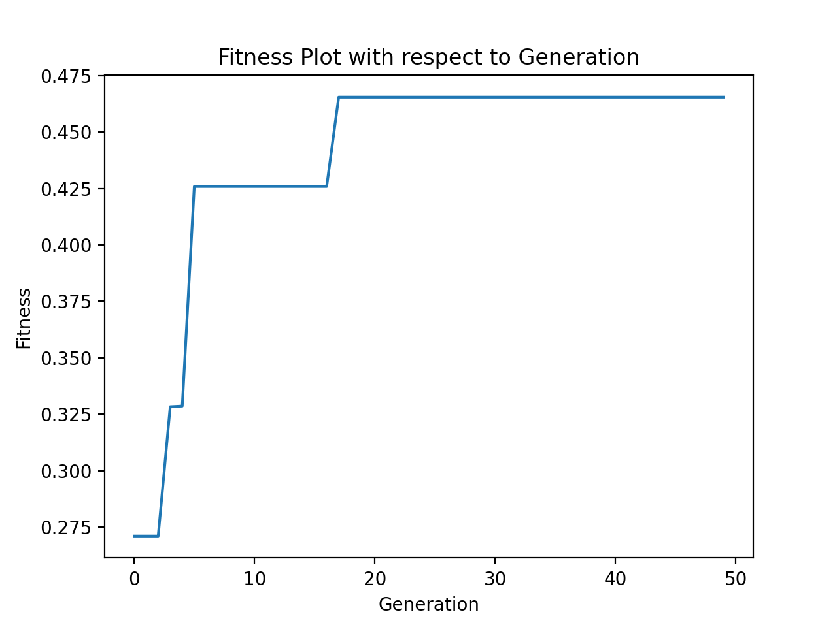

*Fig. 6: Fitness vs. Generations*

The obtained results reveal a consistent increase in fitness values, which directly correspond to the Lyapunov exponent, as the generation number progresses. Moreover, all of these values remain positive throughout. The positive Lyapunov exponent signifies the presence of chaos within the systems, confirming the validity of our approach.

Another measure that shows the genetic algorithm process is visualization of the population throughout generations. Here below every plane corresponding to a single individual is presented with a color, each figure is a generation.

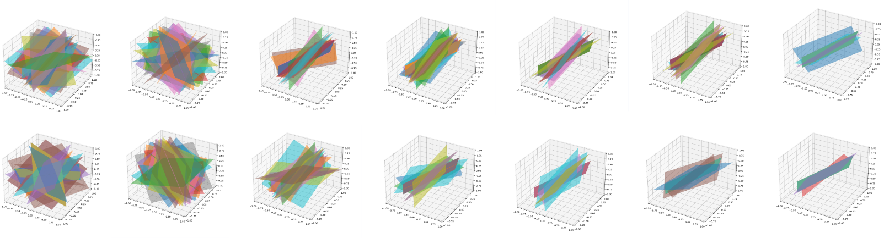

*Fig. 7: Populations Throughout Generations*

Here are the created chaotic attractor systems plotted.

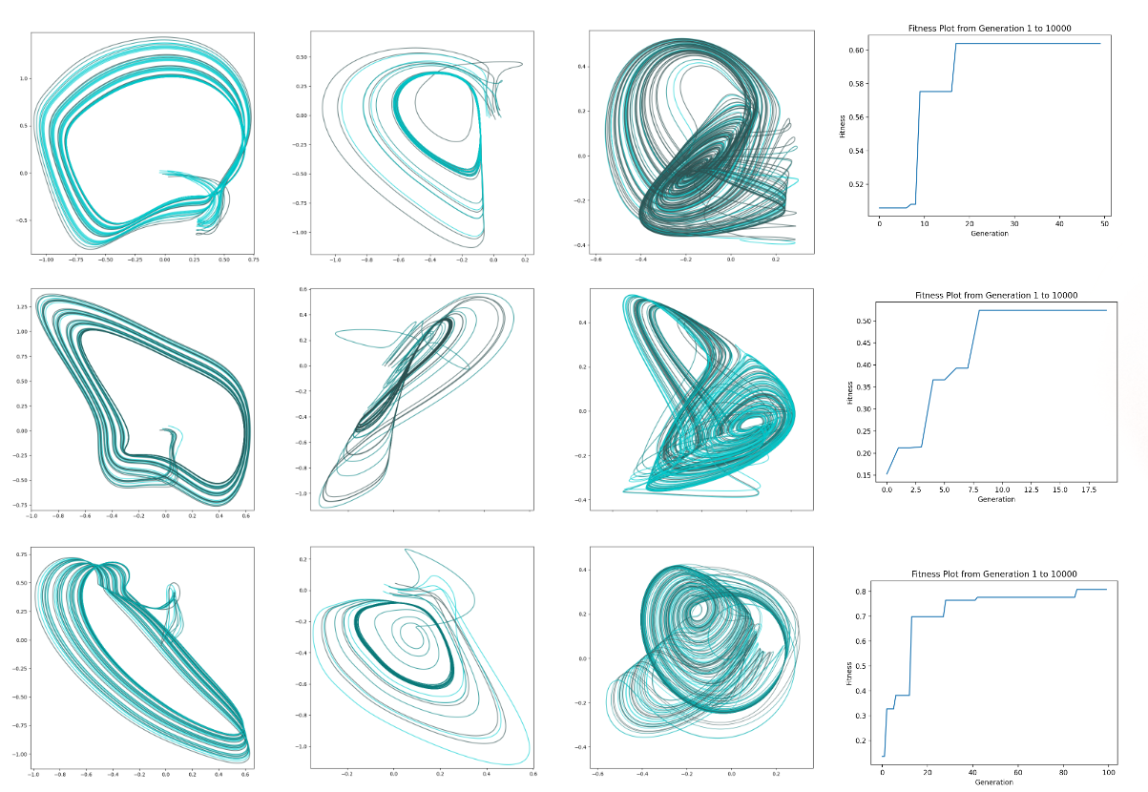

**Projections and Comments**

Initially, it appeared that chaotic systems were uncommon occurrences that existed only under very specific conditions. However, it has become evident that the combination of chaotic systems can also result in chaos, even though the merging process is not straightforward. This observation suggests that analyzing chaotic phenomena using a combination of chaotic attractors is a viable approach, as the dynamics of these systems permit the emergence of new attractors.

**